# X Titan E-Commerce Announcement Board

**Acknowledgement**

It is my pleasure to be indebted to various people, who directly or indirectly contributed in the development of this work and who influenced our thinking, behaviour and acts during the course of study.

We express our sincere gratitude to **Pro. Mr Raed** for providing us an opportunity to undergo this project as the part of the curriculum.

We would like to thank some of our classmates for their support and help from the beginning in the development of the project.

**ABSTRACT**

Our project is X-Titan E-Commerce Site. This is a website which helps student to find and buy some specific type of electronics product on internet. It is useful in the way that it makes an easier way to buy and sell electronics online. X-Titan is an interactive e-commerce solution providing users with an opportunity to buy and sell electronics.

In this website we have basically 2 modules. The first module includes the customer module and second module includes admin module.

The customers have to register for any enquiry related to electronics. The registered customer can view details of electronics and he/she can buy or sell electronic products of his/her need. He/she has to pay and will get home delivery.

The admin module contains the access of admin page on the website. The admin can change everything in the website. He has the ability to add, delete, and update any information regarding the electronic products.

Table of Contents

X Titan E-Commerce Announcement Board 1

Description of The Project: 3

System Database: 3

Features of X-Titan E-Commerce: 4

Requirement Specifications: 4

Software Details: 4

Logic of Each module: 5

Methodology: 5

SYSTEM ANALYSIS: 6

Conclusion: 13

**Introduction:**

Internet has become an important medium for doing global business based on the state-of-the-art technology. Global business was conducted in a new way: electronically, using networks and the Internet. The availability of Internet has led to the development of **E-Commerce,** in which business transactions take place via telecommunication networks. E-Commerce has two major aspects, economical and technological.

An e-Commerce website site is an information technology method in which trader, businesses/distributor/marketers can promote products/services and the client can buy on that internet site electronically by way of using internet on the mobile and computer. It ability an e-commerce internet site is an on line shop. e capacity electronic. Commerce means business. Website skill the team of HTML net pages and that is created to market/sell information/product/services.

When you purchase a cellular phone /shoes/software/ vegetation on any internet site such as Amazon, Flipkart etc. and pay thru credit/debit card and then seller deliver the product thru courier or put up mail on your region then it’s called e-commerce. In this case, Flipkart is an online shop website or an e-commerce website.

When you rent or buy movies on YouTube and pay to watch by means of the usage of the mobile/computer and net it’s known as e-commerce. In this method, you have used computer/mobile and net thru electrical energy and visited YouTube website to watch/buy/rent the movie and paid through debit card/credit card/ internet banking/payment wallet etc. It means YouTube is an e-Commerce internet site in which you can buy/watch/rent the modern-day films and shows.

More and extra commercial enterprise houses are implementing web website online providing performance for performing commercial transactions over the web. X Titan e-commerce web sites supply buyers with less luxurious merchandise and services by means of allowing them to shop in many places and behavior rapid comparisons. E-Commerce which used to be commenced in early 1990’s has taken a gorgeous bounce in the world of computers; however, the fact that has hindered the increase of e-commerce is security. Customer selected some items, but in his credit or debit cart haven’t that a good deal balance, then he was once logout from the website, the chosen items are stored at cart with unique customers with his disbursed carts, after some days he sold those objects then automatically deleted from the cart.

# Description of The Project:

X Titan E-Commerce portal which will enable formal and informal merchants in developing countries to promote and sell their goods on the internet. This would permit rural communities to make their wares on hand to the rest of the world through the World Wide Web.

The objective of this task is to create an e-commerce web portal with a content material management system which would permit product statistics to be up to date securely using a cell device. The internet portal will have an on line interface in the form of X Titan e-commerce website that will enable users to buy items from the merchants.

# System Database:

The product, merchant and customer database will store all information about the products that will be sold on the e-commerce portal (prices, product descriptions, photos of products). It will also store merchant information (names, banking details, contact details) as well as customer details (profile details, shipping address). This database will use the MySQL architecture and will be manipulated using SQL queries via the content management system.

# Features of X-Titan E-Commerce:

* An online shop that will allow online buyers to buy wares from formal and informal merchants
* A search engine on the internet site to permit customers to find particular sorts of merchandise.
* An invulnerable on line transaction system that will enable shoppers to buy items safely using them savings cards.
* A database of merchandise with photos, product descriptions and stock information. This database will additionally incorporate all applicable merchant and customer information.
* An information protection machine that will make sure that all records that is transmitted between the various system.

# Requirement Specifications:

For putting this ecommerce portal, it requires certain technical requirements to be met for the save to function properly. First, an internet server has to be created to make the ecommerce save publicly handy on the web. Domain names and internet hosting services can without problems be purchased for an inexpensive price. When choosing a web hosting service, you have to take a look at to see that these server necessities are supplied and established on their web servers.

# Software Details:

* Web Server (preferably Apache)
* PHP (at least 5.2)
* MySQL
* Curl
* HTML
* Bootstrap

# Logic of Each module:

**Orders Module:** When a customer goes through checkout, the information on their order is automatically transferred to the Orders section for you to keep track of. In the administration, you can view all of the orders made on their site, manually add orders, or edit the details of existing orders. The Orders section is located under details > buy now. On this page, every order ever made from the store is listed in detail.

**Customer Module:** Shop owners should know who their customers are and how to manage their information. In the administration, customer information will need to be stored efficiently to remember any transactions made with their account. To access customer information, you can log into the administration panel of the Open Cart store. The Customer management sections are located under login > Customers.

**Profiles Module:** Profiles are a new, optional feature in Open Cart. They allow you to set up recurring payments for your customers. Profiles are useful if you plan to sell products by subscription, if you are promoting a discount or member's club, or if you are simply breaking up payments into smaller portions. This feature gives the store owner more control over how customers are charged for products or services.

**Categories Module:** In the default theme of the store front, parent categories are listed in the top menu of the home page, and on the left side of product pages. This navigational feature is used to guide customers to similar products within the same category. Exposing customers to different products within a category lets the customer compare the similarities and differences between products to make the most informed purchase. When adding products to the store, you will be asked for a product category to sort them in. It is a good idea to establish these categories before adding products, to save yourself the trouble of adding the category name to the products later.

# Methodology:

Model View Controller or MVC as it is popularly called, is a software program format sample for creating internet applications. A Model View Controller sample is made up of the following three parts:

* Model - The lowest level of the sample which is responsible for keeping data.
* View - This is responsible for exhibiting all or a portion of the facts to the user.
* Controller - Software Code that controls the interactions between the Model and View.

MVC is popular as it isolates the utility logic from the user interface layer and helps separation of concerns. Here the Controller receives all requests for the application and then works with the Model to prepare any information needed via the View. The View then uses the records organized with the aid of the Controller to generate a final presentable response. The MVC abstraction can be graphically represented as follows.

**Customer:** The Customer Reports section can be accessed under Reports>Customers. These reports display specific information to track orders made, reward points, and store credit for each customer using the store.

**Order:** The Order Report section can be accessed under Reports>Customers>Orders. The following information will be displayed about customer orders:

* Customer Name
* E-Mail
* Status: Shows if the customer is currently allowed to login to their store account.
* No. Orders: The total number of orders made by this customer.
* No. Products: The total number of products purchased by this customer.
* Total: The total amount purchased from this customer. Customers are arranged on the list from the highest amount to the lowest.

# SYSTEM ANALYSIS:

**1. Existing System**

Existing system is a manual one in which users are maintaining books to store the information like product details, Distributors details, purchases, sales details and accounts for every month. It is very difficult to maintain historical data.

**2. Proposed System**

The DISTRIBUTORS MANAGEMENT TOOL is a software application which avoids more manual hours that need to spend in record keeping and generating reports. This application keeps the data in a centralized way which is available to all the users simultaneously. It is very easy to manage historical data in database. No specific training is required for the distributors to use this application. They can easily use the tool that decreases manual hours spending for normal things and hence increases the performance. It is very easy to record the information of online sales and purchases in the databases.

**3. Objective of the System**

The objective of the Distributors Management Tool is to provide better information for the users of this system for better results for their maintenance in the product details that is sales, purchases and stock.

**Website Screenshot:**

**Home Page**

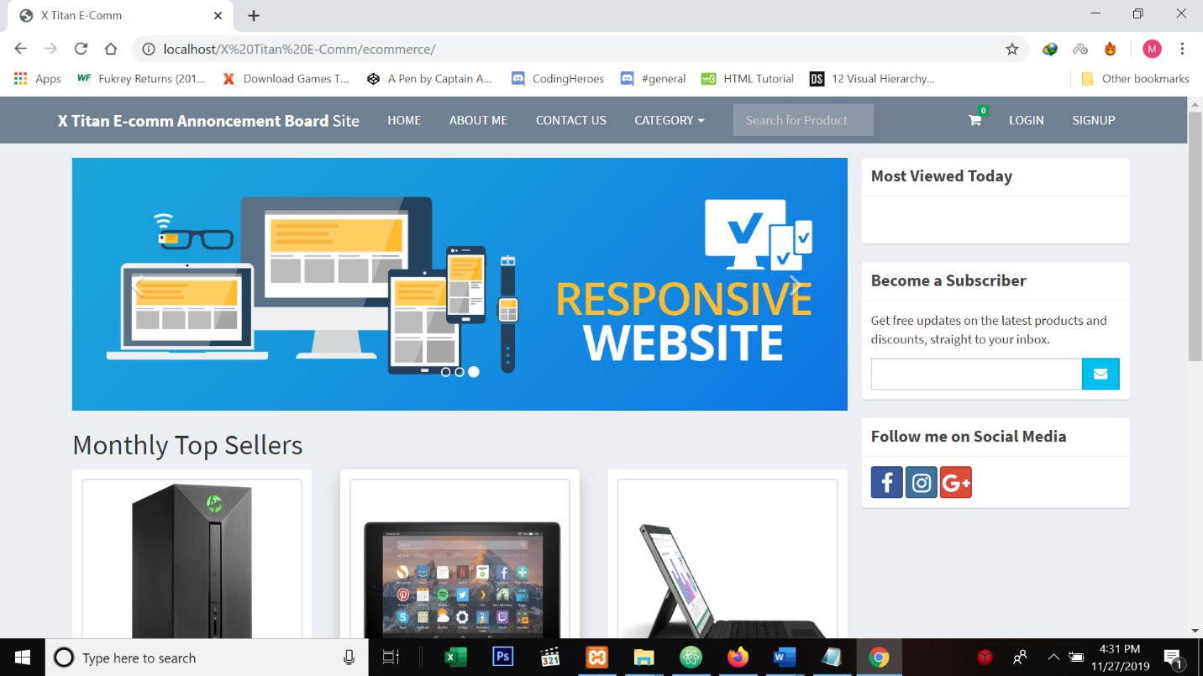

**Sign Up Page**

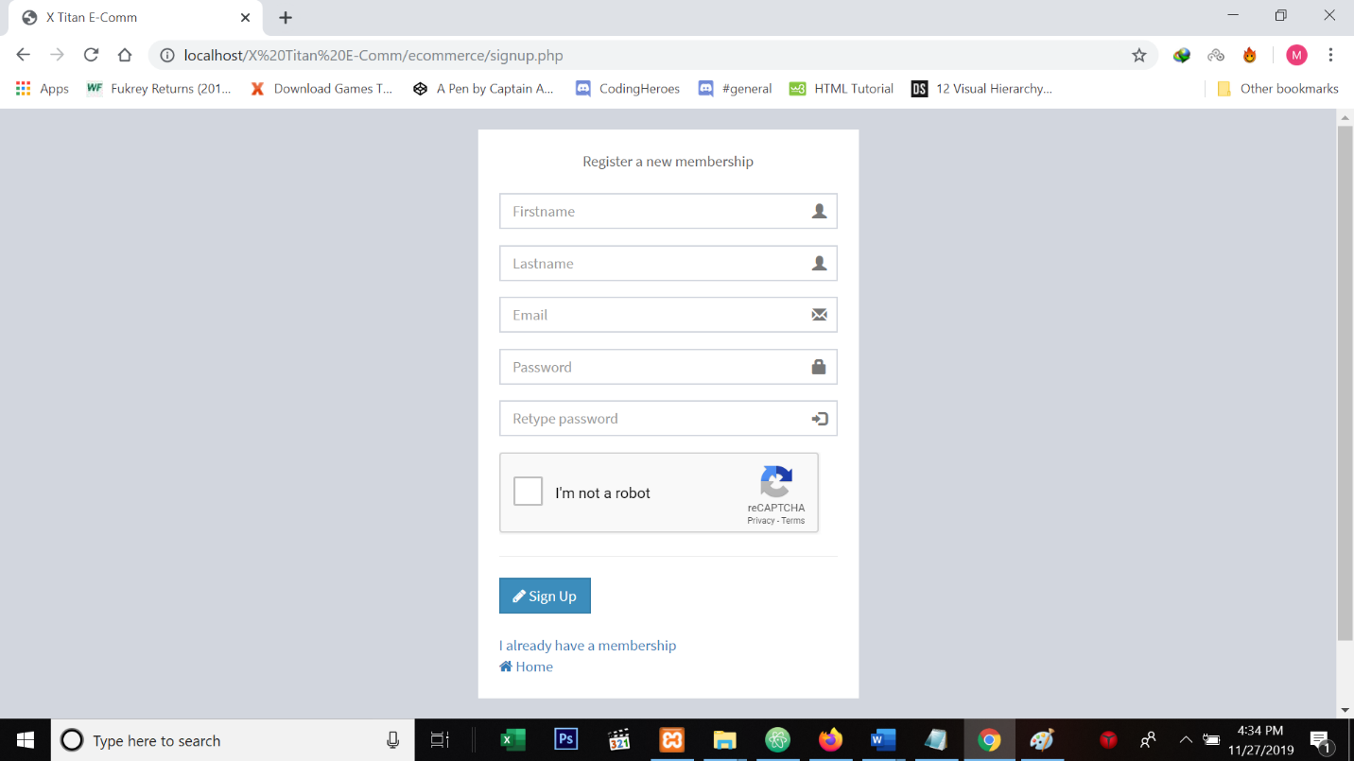

**Log In page**

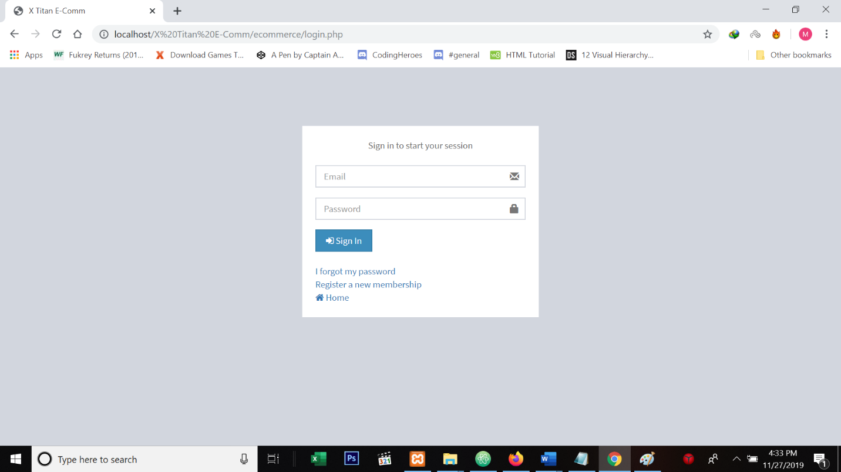

**Product List Page**

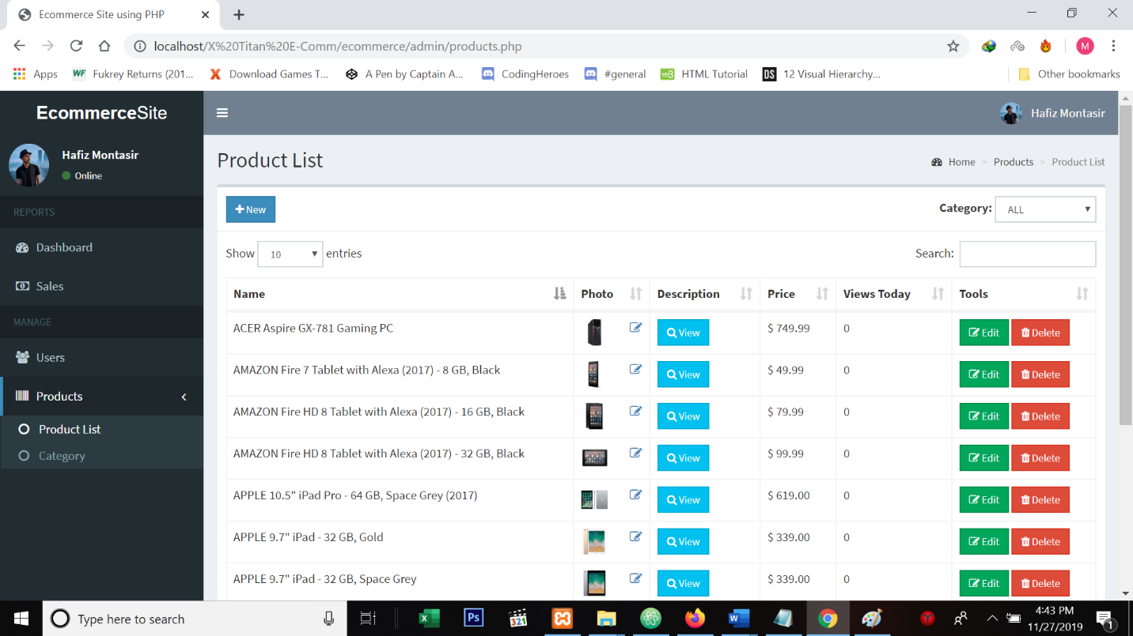

**Product Category Page:**

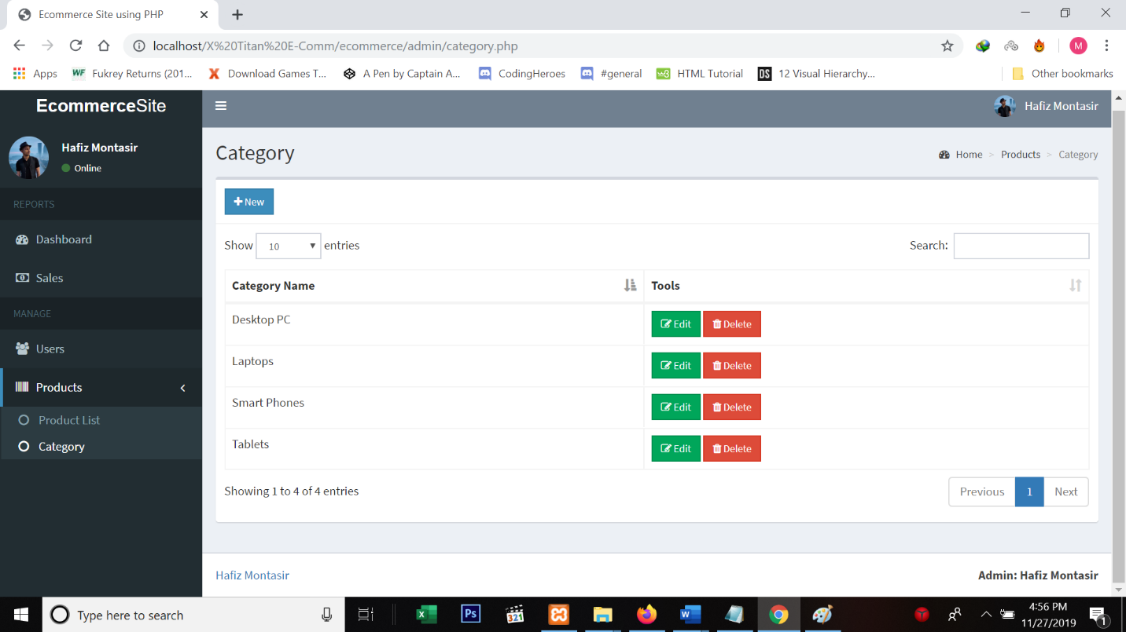

**Search Page:**

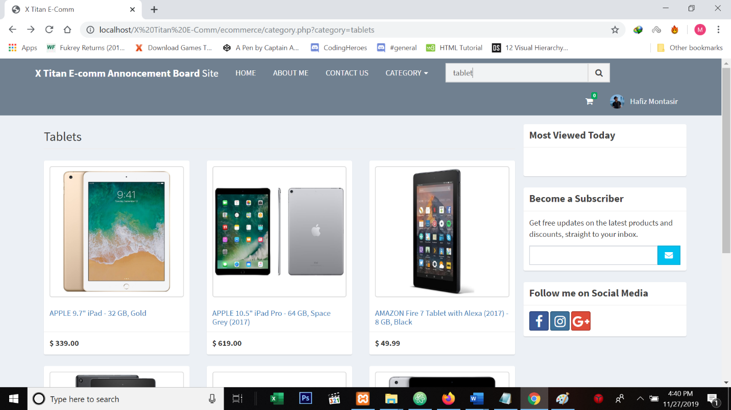

**Sales Page:**

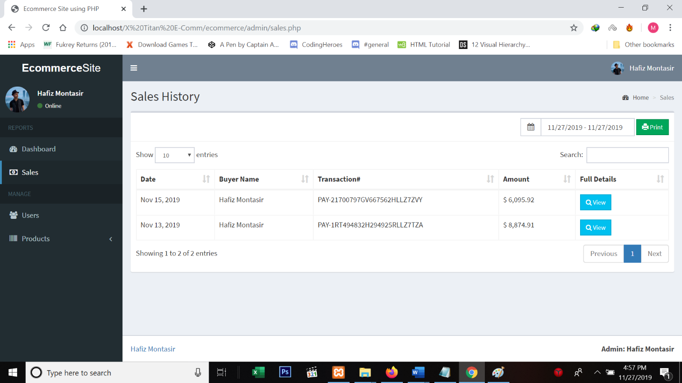

**Customer Profile Page:**

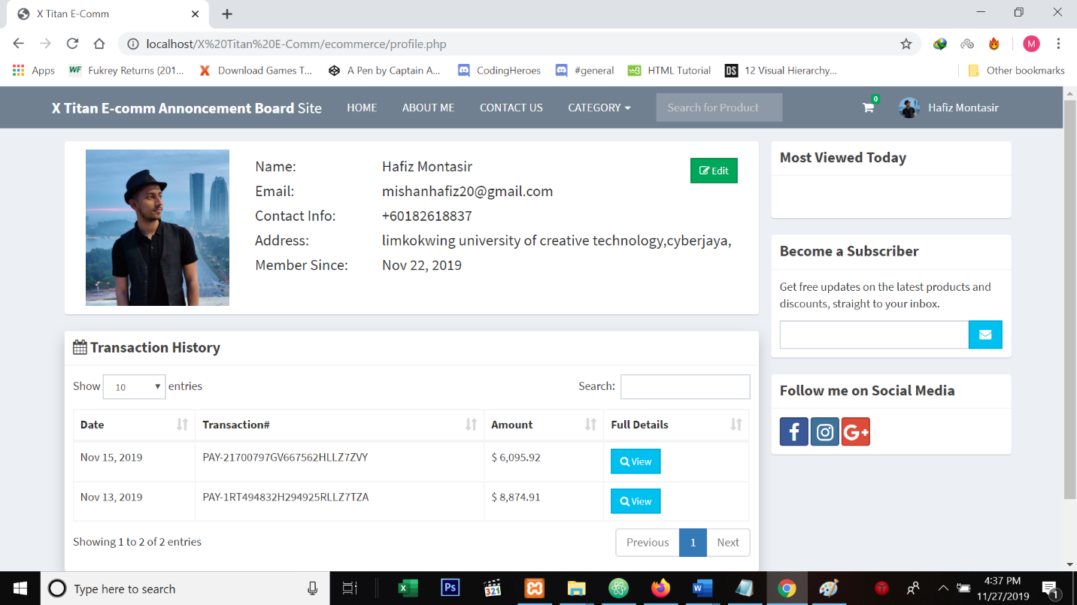

**Admin Page:**

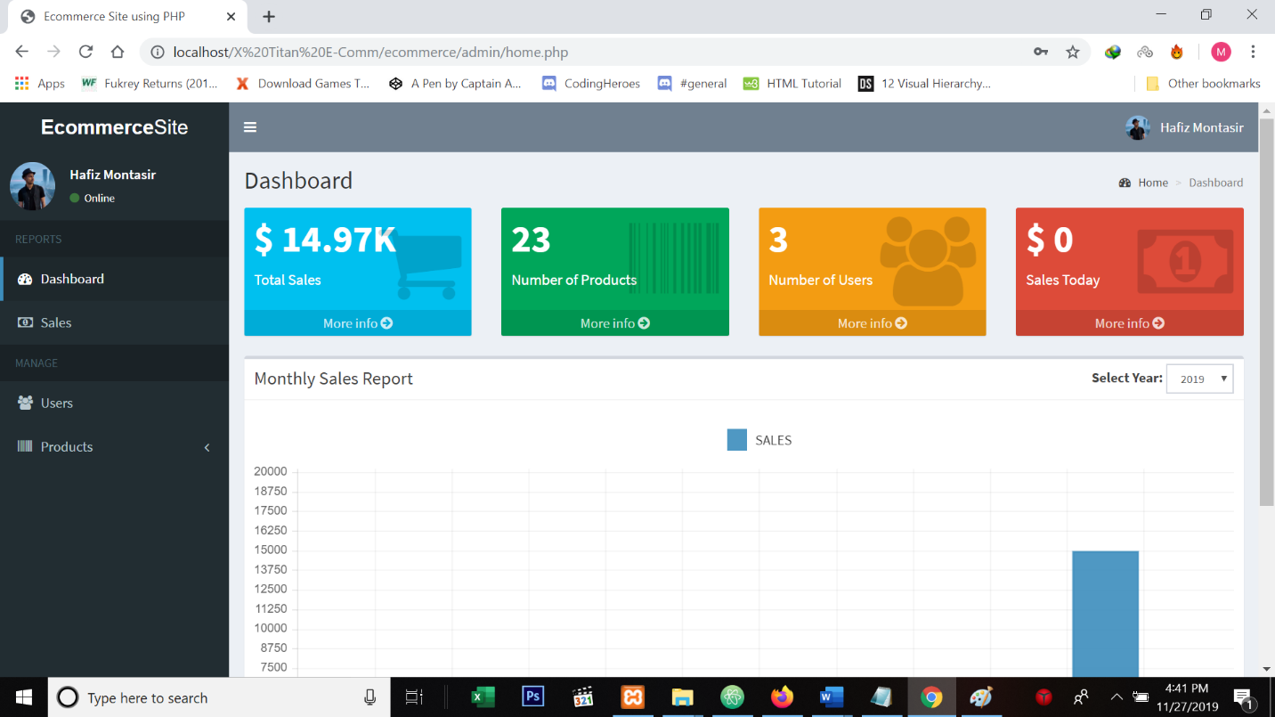

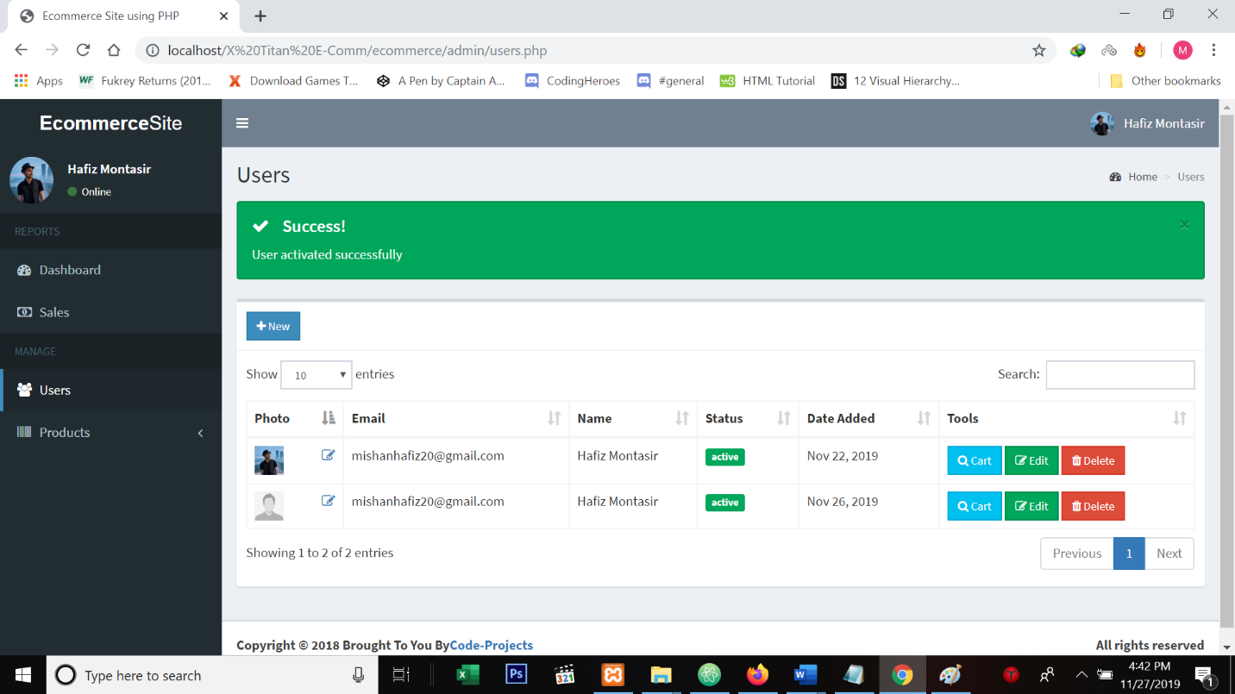

**Database/PHPmyadmin:**

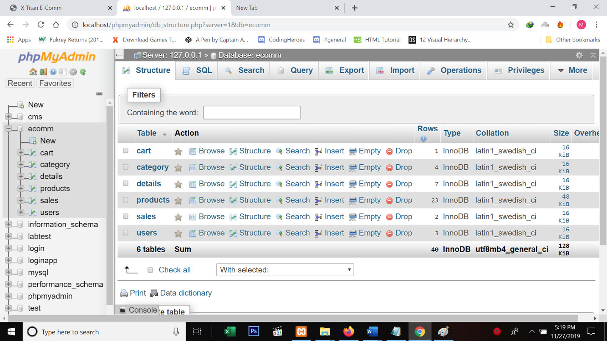

**Payment**

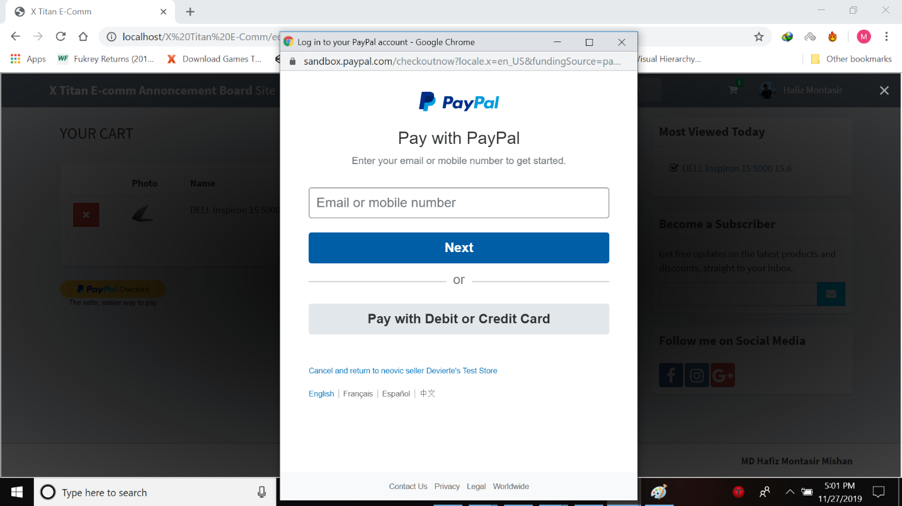

# Conclusion:

In general, today’s businesses must always strive to create the next best thing that consumers will want because consumers continue to desire their products, services etc. to continuously be better, faster, and cheaper.  In this world of new technology, businesses need to accommodate to the new types of consumer needs and trends because it will prove to be vital to their business’ success and survival.  E-commerce is continuously progressing and is becoming more and more important to businesses as technology continues to advance and is something that should be taken advantage of and implemented.

From the inception of the Internet and e-commerce, the possibilities have become endless for both businesses and consumers.  Creating more opportunities for profit and advancements for businesses, while creating more options for consumers.  However, just like anything else, e-commerce has its disadvantages including consumer uncertainties, but nothing that cannot be resolved or avoided by good decision-making and business practices.

There are several factors and variables that need to be considered and decided upon when starting an e-commerce business.  Some of these include: types of e-commerce, marketing strategies, and countless more.  If the correct methods and practices are followed, a business will prosper in an e-commerce setting with much success and profitability.

**References:**

Electronic Privacy Information Center's Clipper Chip page, [http://www.epic.org/crypto/clipper](http://www.epic.org/crypto/clipper/).

Francis Litterio's Cryptography resource center,   
[http://world.std.com/~franl/crypto/info.html](http://world.std.com/%7Efranl/crypto/info.html).

Greg Shipley, Certificate Authorities: How Valuable Are They? TechWeb News (March 25, 1997),   
<http://www.networkcomputing.com/806/806f1.html>.

Internet Law & Policy Forum, The Role Of Certification Authorities In Consumer Transactions(1997),   
<http://www.ilpf.org/work/ca/draft.htm>.

Internet2's collection of sample certificates,  
<http://middleware.internet2.edu/certprofiles/>.

John Palfrey, [Security and the Basics of Encryption in E-Commerce](https://cyber.harvard.edu/olds/encrypt.html) (2001).